# [Model Registry Workflows](https://www.mlflow.org/docs/latest/model-registry.html" \l "id2)

If running your own MLflow server, you must use a database-backed backend store in order to access the model registry via the UI or API. [See here](https://www.mlflow.org/docs/latest/tracking.html" \l "backend-stores) for more information.

Before you can add a model to the Model Registry, you must log it using the log_model methods of the corresponding model flavors. Once a model has been logged, you can add, modify, update, transition, or delete model in the Model Registry through the UI or the API.

## [UI Workflow](https://www.mlflow.org/docs/latest/model-registry.html#id3)

### [Registering a Model](https://www.mlflow.org/docs/latest/model-registry.html#id4)

1. From the MLflow Runs detail page, select a logged MLflow Model in the **Artifacts** section.
2. Click the **Register Model** button.

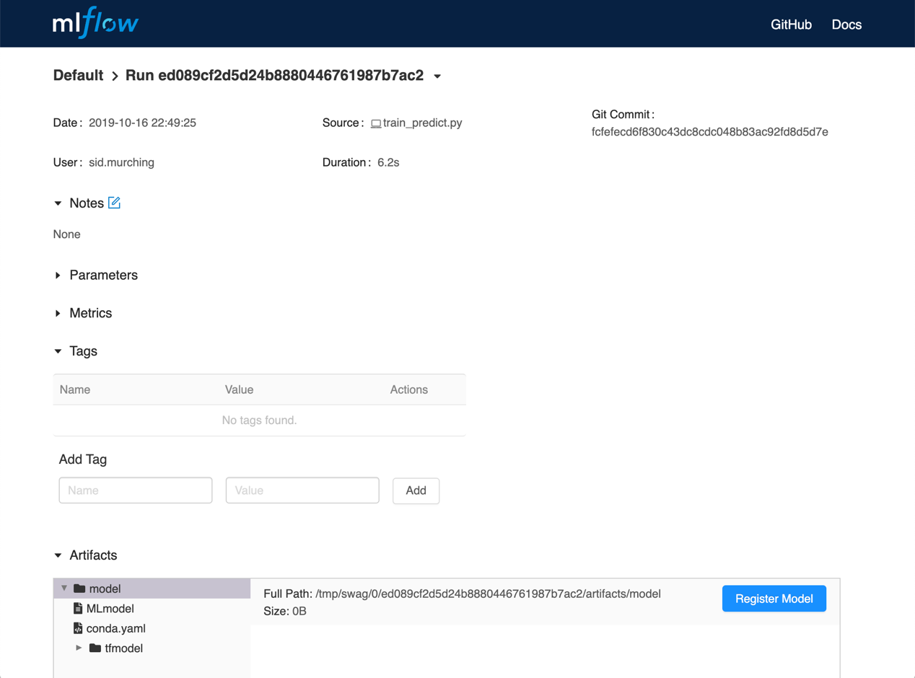

1. In the Model Name field, if you are adding a new model, specify a unique name to identify the model. If you are registering a new version to an existing model, pick the existing model name from the dropdown.

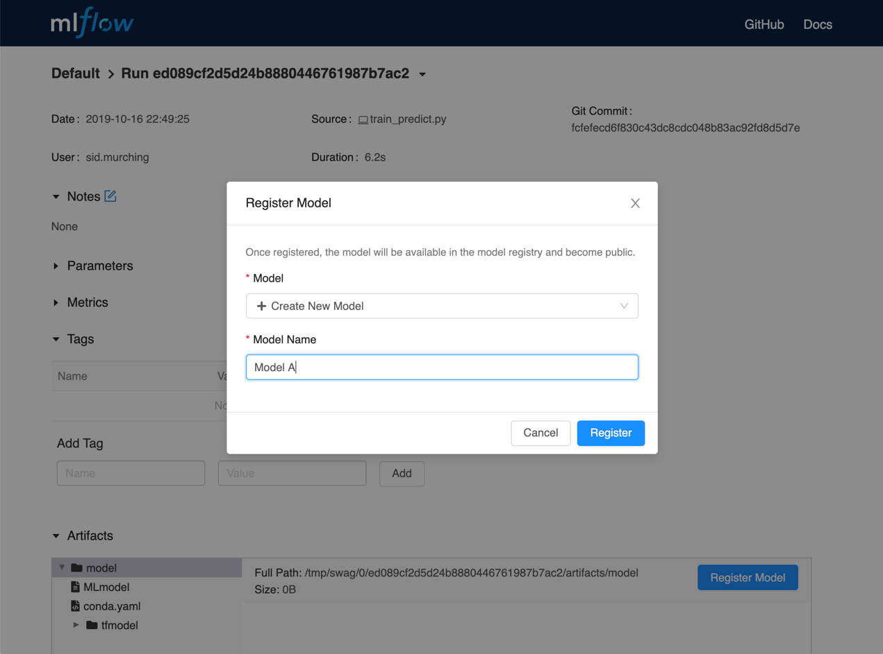

### [Using the Model Registry](https://www.mlflow.org/docs/latest/model-registry.html#id5)

* Navigate to the **Registered Models** page and view the model properties.

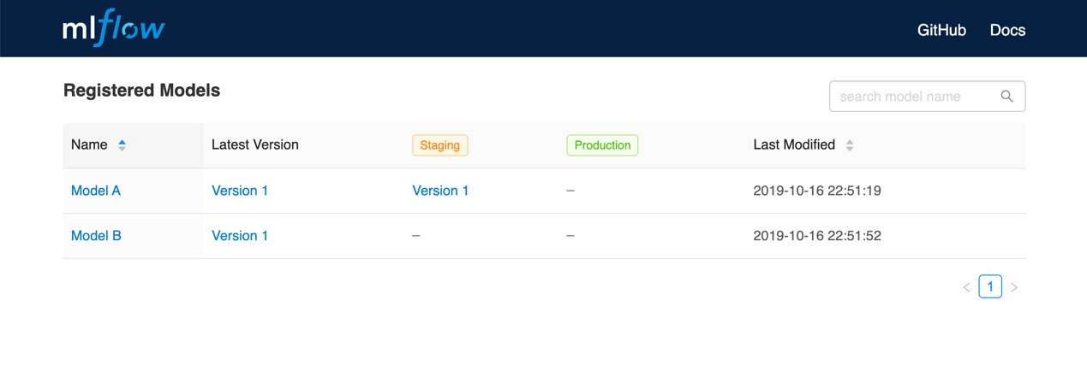

* Go to the Artifacts section of the run detail page, click the model, and then click the model version at the top right to view the version you just created.

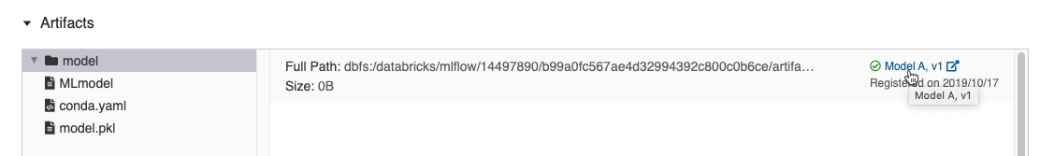

*Each model has an overview page that shows the active versions.*

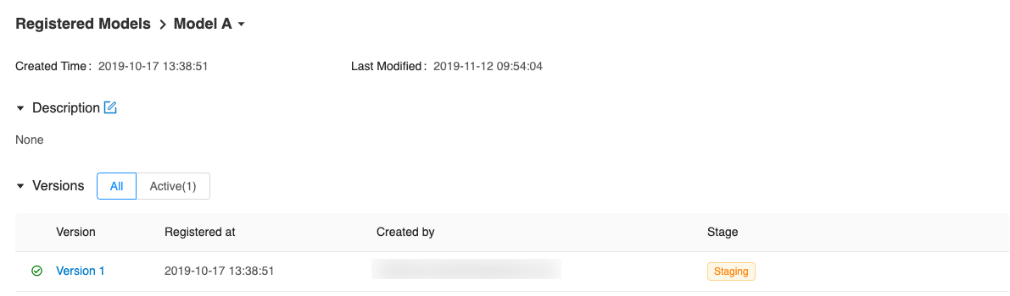

*Click a version to navigate to the version detail page.*

Εικόνα που περιέχει κείμενο

Περιγραφή που δημιουργήθηκε αυτόματα

*On the version detail page you can see model version details and the current stage of the model version. Click the Stage drop-down at the top right, to transition the model version to one of the other valid stages.*

Εικόνα που περιέχει κείμενο

Περιγραφή που δημιουργήθηκε αυτόματα